31) Aim: To Design Push Down Automata using simulator to accept the input string anbn over input alphabets ∑ = {0, 1}.

Diagram:

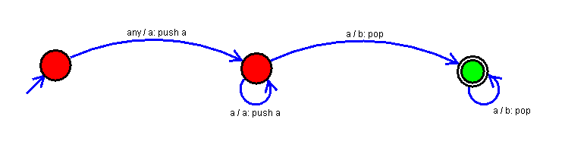

Result:

Successfully executed Push Down Automata using simulator to accept the input string anbn over input alphabets ∑ = {0, 1}.